Add User to Linux Machine  
  
Ubuntu

1.Connect to ubuntu vm using public ip , and login as user



2.reset the root user password and login as root user

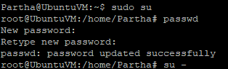

3.display the list of users on vm

a. cut -d: -f1 /etc/passwd

This command extracts the usernames from the **/etc/passwd** file, which stores user account information.

b. getent passwd | cut -d: -f1

the “getent” retrives user information

c. awk -F: '{print $1}' /etc/passwd

awk-F prints the user name

above 3 cmd gives same types of output

d. ls /home

list all the user’s names from home directory

4. Add new user

Adding new user name as jaya

->sudo adduser jaya

Password:- Jaya@123

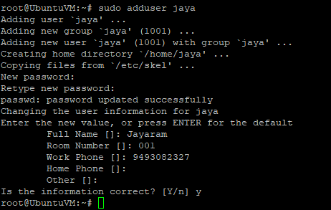

Verify user added

->ls /home



Login as “jaya” new user, trying to reboot the system but sudo (admin access) don’t have for this user

Allow admin access to “jaya”

->sudo usermod -aG sudo jaya

User will be added to sudo group so user will have administrator permission

Try to run sudo cmd from user jaya, using sudo rebbot to restart the vm

